# **Logging into StudySync from a School Computer for CVS Middle School Students**

StudySync is set up to log you in automatically from a school computer. Follow these steps to get to Study Sync when you’re at school.

1. Start by logging into the computer using your student number and password.
   1. NOTE: If you use a generic login for the computer, or another person’s login this will not work correctly.
2. Click the Study Sync Icon

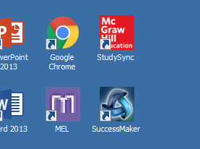

1. The internet will be launched and you will be at your personal Study Sync page.